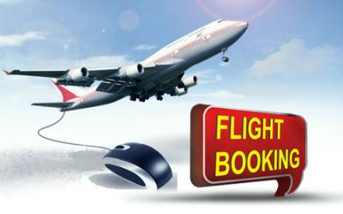

**Designed By:**

**A**

**PROJECT REPORT**

**ON**

**FLIGHT RESERVATION**

**ROHIT SINGH(IT/16/021)**

**SOURIN PARI(IT/16/011)**

**RITIKA RATAWA(IT/16/030)**

**RITIKA RUNGTA(IT/16/013)**

**NITISH KUMAR(IT/16/005)**

**ACKNOWLEDGEMENT**

I would like to take this opportunity to express my gratitude towards all the people who have helped in the successful completion of my project.

I must convey my gratitude to Ms. .......................

for giving me the constant source of inspiration and help in preparing the project, personally correcting my work and providing me encouragement throughout the project. I also thank all my faculty members for steering me through the tough as well as easy phases of the project in a result oriented manner with concern attention.

**CERTIFICATE**

This is to certify that this is a bona fide record to the project work done satisfactorily at **MCKVIE** by students of 4th Semester .This report or the similar report on this topic has not been submitted for any other examination and does not form part of any other course undergone by the candidate . ___________________________________ Signature of Project GuideName:

CONTENTS :-

1. Introduction

2. Requirement analysis

3. Hardware and software requirements

4. Software design: DFD &ERD

5. Coding

6. Testing

7. Sample Output

8. Deployment

9. Scope for future work

10. References

**OBJECTIVE**

The main goal of the proposed system is to make online the processes of the air ticket reservation and cancelation system.

INTRODUCTION

In today’s airline industry users or customers can reserve seat or book flight from any place in the world as long as they are connected to internet. The Innovation of technology has made traveling in the air easier for customers with airline reservation or booking just a click away. This project also covers various features like online registration of the users, modifying the details of the website by the management staff or administrator of the website, by adding, deleting or modifying the customer details, flights or packages information. In general, this website would be designed to perform like any other airline ticketing website available online.

Over the years with the advent of internet, online ticket booking for airline travel has been increasingly popular. The main focus of airline companies today has been in the satisfaction of customers. The companies are doing this by making journeys possible in a fully mobile and social environment with the intelligent use of vast quantities of data to deliver real service and operational improvements. The personalized use of mobile phones and web by customers is expected to increase drastically, with the estimation of 90% airline companies offering mobile check-in. 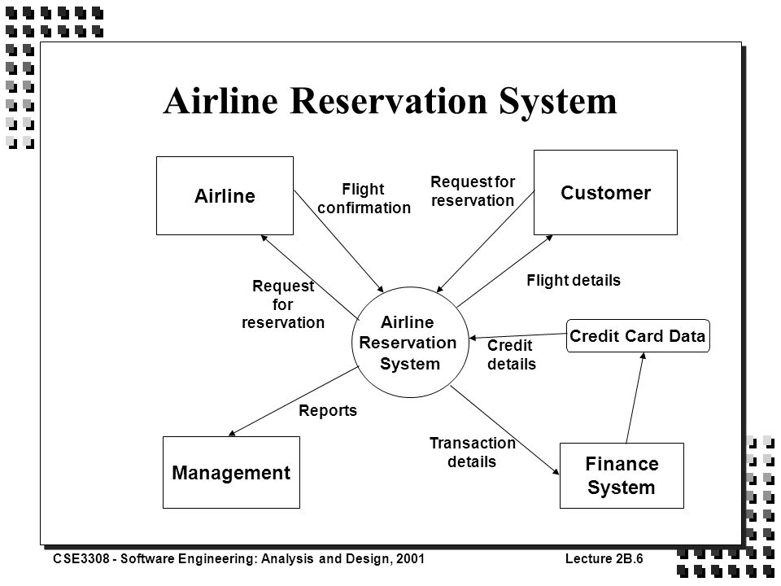

Requirement Analysis

For the implementation of my project the minimum

HARDWARE AND SOFTWARE REQUIREMENT

Hardware and Software requirement are as follows :-

Minimum Hardware Requirements :-

Pentium III @500 MHz or above,

RAM 256 MB

**HD space required**:

> Space required for installation:

> 500 MB.

**Space required after installation**:

6 GBCD Rom drive 24x Windows 2000/2000 server, XP enterprise,

Software Requirements :-

Vista or Windows 7Microsoft office Access/ Oracle 8 or above Microsoft office word Microsoft .net framework . In this phase initially I had designed E-R diagram of the processes, in order to identify various entities and relationship set ,entity set ,attributers, link attributes The Diagram of this process asunder. The symbol of entities are shown bellow :- LINE In order to design a better solution. I had designed the DFD for system including all technical processing details is given bellow: FLIGHT INWARD DETAILS OUTWARD STORES

Software Design

**RELATIONSHIP SETS**

ENTITY SETS

**DATA FLOW DIAGRAM**

FLIGHT DETAILS 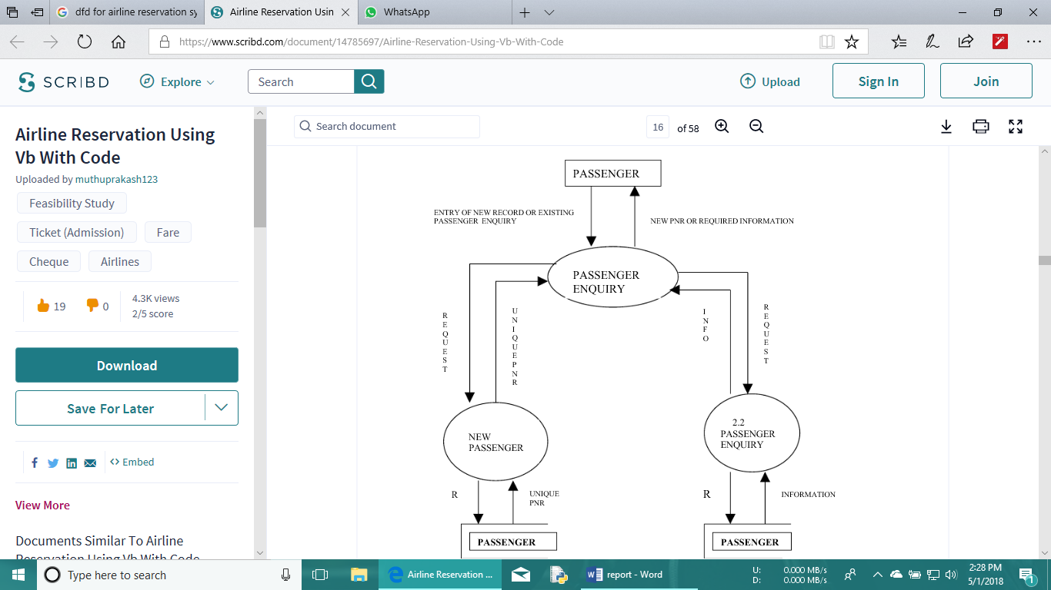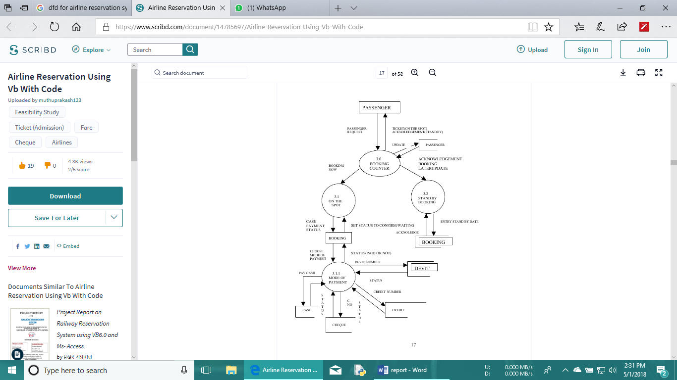 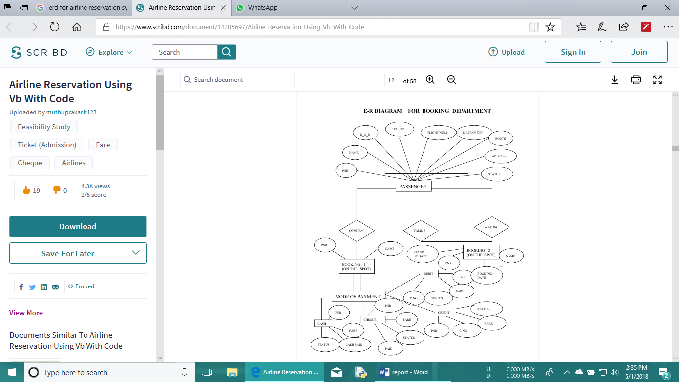

**RESERVATION**

CODING

**1. Account Creation**

**Private Sub Command1_Click()**

If Text1.Text = "" Then

MsgBox "Ener Ur user name "

Else

If Text2.Text = "" Then

MsgBox "Enter Ur name"

Else

If Text4.Text = "" Then

MsgBox "Enter Ur Age"

Else

If Text5.Text = "" Then

MsgBox "Enter ur mail id "

Else

If Text6.Text = "" Then

MsgBox "Enter ur password "

Else

MsgBox "Account Creation Successful"

Unload Me

Load login

login.Show

End If

End If

End If

End If

End If

Data1.Recordset.AddNew

End Sub

**Private Sub Command2_Click()**

Unload Me

Load login

login.Show

End Sub

**Private Sub Text3_Change()**

Text3.Text = DTPicker1.Value

End Sub

**Private Sub Text4_Change()**

If Not IsNumeric(Text4) Then MsgBox "Please Enter Numerical Values only"

End Sub **2. User Login**

**Private Sub Command1_Click()**

If Text1.Text = "" Or Text2.Text = "" Then

MsgBox "Invalid User ID or Password"

Else

Unload Me

Load journey

journey.Show

Data1.Recordset.AddNew

End If

End Sub

**Private Sub Command2_Click()**

Unload Me

Load front

front.Show

End Sub

**Private Sub Command3_Click()**

Unload Me

Load Create

Create.Show

Create.Data1.Recordset.AddNew

End Sub

**Private Sub Command4_Click()**

Unload Me

Load front

front.Show

End Sub

**Private Sub Form_Load()**

Label1.Caption = Label1.Caption & Space(20)

Timer1.Enabled = True

End Sub

**Private Sub Timer1_Timer()**

Dim str As String

str = login.Label1.Caption

str = Mid$(str, 2, Len(str)) + Left(str, 1)

login.Label1.Caption = str

End Sub

**3. Journey Details**

**Private Sub Command1_Click()**

If Combo1 = Combo2 Then

MsgBox "Enter two different cities "

Else

Timer2.Enabled = True

Label6.Visible = True

Label8.Visible = True

ProgressBar1.Visible = True

End If

Printticket.Text5.Text = Combo1.Text

End Sub

**Private Sub Command2_Click()**

Unload Me

Load login

login.Show

End Sub

**Private Sub Form_Load()**

Label1.Caption = Label1.Caption & Space(20)

Timer1.Enabled = True

Combo1.AddItem ("Mumbai(BOM)")

Combo1.AddItem ("New Delhi(DEL)")

Combo1.AddItem ("Bengaluru(BLR)")

Combo1.AddItem ("Chennai(MAA)")

Combo1.AddItem ("Kolkata(CCU)")

Combo1.AddItem ("Lucknow(LKO)")

Combo2.AddItem ("Mumbai(BOM)")

Combo2.AddItem ("New Delhi(DEL)")

Combo2.AddItem ("Bengaluru(BLR)")

Combo2.AddItem ("Chennai(MAA)")

Combo2.AddItem ("Kolkata(CCU)")

Combo2.AddItem ("Lucknow(LKO)")

Combo5.AddItem ("Economy")

Combo5.AddItem ("Business")

Combo5.AddItem ("Premium Economy")

End Sub

**Private Sub Timer1_Timer()**

Dim str As String

str = journey.Label1.Caption

str = Mid$(str, 2, Len(str)) + Left(str, 1)

journey.Label1.Caption = str

End Sub

**Private Sub Timer2_Timer()**

Timer2.Interval = Rnd * 300 + 10

ProgressBar1.Value = ProgressBar1.Value + 10

Label6.Caption = ProgressBar1.Value & "%"

If Label6.Caption = 100 & "%" Then

MsgBox "Searched Completed"

Unload Me

Load fdetail

fdetail.Show

End If

End Sub

**4. Flight Details**

**Private Sub Command1_Click()**

Printticket.Text12.Text = 2200

nbpay.Text2.Text = 2200

Pasdetail.Text1.Text = "G8-530"

Printticket.Text3.Text = "G8-530"

Unload Me

Load Pasdetail

Pasdetail.Show

End Sub

**Private Sub Command2_Click()**

Printticket.Text12.Text = 3200

nbpay.Text2.Text = 3200

Pasdetail.Text1.Text = "G7-456"

Printticket.Text3.Text = "G7-456"

Unload Me

Load Pasdetail

Pasdetail.Show

End Sub

**Private Sub Command3_Click()**

Printticket.Text12.Text = 2500

nbpay.Text2.Text = 2500

Pasdetail.Text1.Text = "A3-789"

Printticket.Text3.Text = "A3-789"

Unload Me

Load Pasdetail

Pasdetail.Show

End Sub

**Private Sub Command4_Click()**

Printticket.Text12.Text = 1200

nbpay.Text2.Text = 1200

Pasdetail.Text1.Text = "S4-567"

Printticket.Text3.Text = "S4-567"

Unload Me

Load Pasdetail

Pasdetail.Show

End Sub

**Private Sub Command5_Click()**

Printticket.Text12.Text = 2000

nbpay.Text2.Text = 2000

Pasdetail.Text1.Text = "R5-453"

Printticket.Text3.Text = "R5-453"

Unload Me

Load Pasdetail

Pasdetail.Show

End Sub

**Private Sub Command6_Click()**

Printticket.Text12.Text = 3200

nbpay.Text2.Text = 3200

Pasdetail.Text1.Text = "A5-234"

Printticket.Text3.Text = "A5-234"

Unload Me

Load Pasdetail

Pasdetail.Show

End Sub

**Private Sub Command7_Click()**

Unload Me

Load journey

journey.Show

End Sub

**Private Sub Form_Load()**

List1.AddItem "G8-530 7:00 9:00 2hrs Rs. 2200"

List1.AddItem " "

List1.AddItem "G7-456 6:30 8:30 2hrs Rs. 3200"

List1.AddItem " "

List1.AddItem "A3-789 5:00 7:00 2hrs Rs. 2500"

List1.AddItem " "

List1.AddItem "S4-567 7:00 9:00 2hrs Rs. 1200"

List1.AddItem " "

List1.AddItem "R5-453 8:00 10:00 2hrs Rs. 2000"

List1.AddItem " "

List1.AddItem "A5-234 6:00 8:00 2hrs Rs. 3200"

End Sub

**5. Passengers Details**

**Private Sub Command1_Click()**

Unload Me

Load fdetail

fdetail.Show

End Sub

**Private Sub Command2_Click()**

If Text7.Text = "" Or Text8.Text = "" Then

MsgBox "Enter ur Name and Age"

Else

Unload Me

Load Payment

Payment.Show

End If

End Sub

**Private Sub Command3_Click()**

Text1.Text = ""

End Sub

**Private Sub Form_Load()**

Combo1.AddItem "Male"

Combo1.AddItem "Female"

End Sub

**Private Sub Text10_Change()**

If Not IsNumeric(Text10) Then MsgBox "Please Enter Numerical Values only"

End Sub

**Private Sub Text12_Change()**

If Not IsNumeric(Text12) Then MsgBox "Please Enter Numerical Values only"

End Sub

**Private Sub Text2_Change()**

Text2.Text = journey.Combo1

End Sub

**Private Sub Text7_Change()**

Printticket.Text9.Text = Text7.Text

End Sub

**Private Sub Text8_Change()**

Printticket.Text11.Text = Val(Text8.Text)

If Not IsNumeric(Text8) Then MsgBox "Please Enter Numerical Values only"

End Sub

**6. Payment Details**

**Private Sub Command1_Click()**

Unload Me

Load Card

Card.Show

End Sub

**Private Sub Command2_Click()**

Unload Me

Load Netbanking

Netbanking.Show

End Sub

**Private Sub Command3_Click()**

Unload Me

Load Printticket

Printticket.Show

End Sub

**7. Print Ticket**

**Private Sub Command1_Click()**

MsgBox "Printing Ur Ticket"

End Sub

**Private Sub Command2_Click()**

Unload Me

Load Payment

Payment.Show

End Sub

**Private Sub Text11_Change()**

Text11.Text = Pasdetail.Text8.Text

End Sub

**Private Sub Text5_Change()**

Text5.Text = Val(journey.Combo1)

End Sub 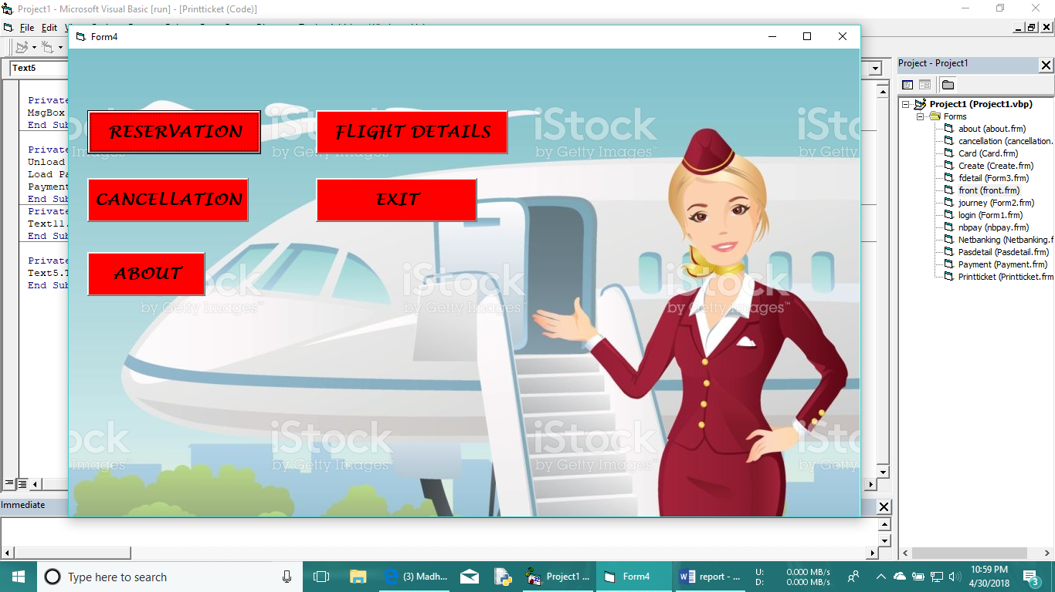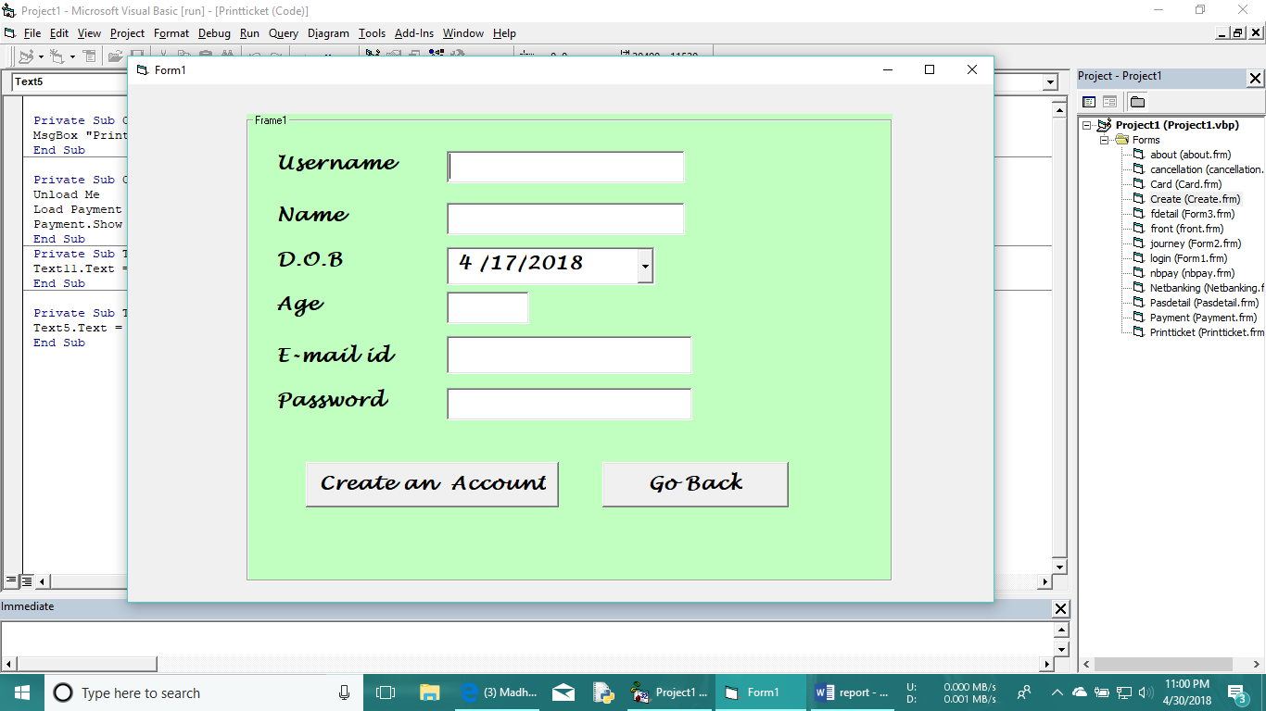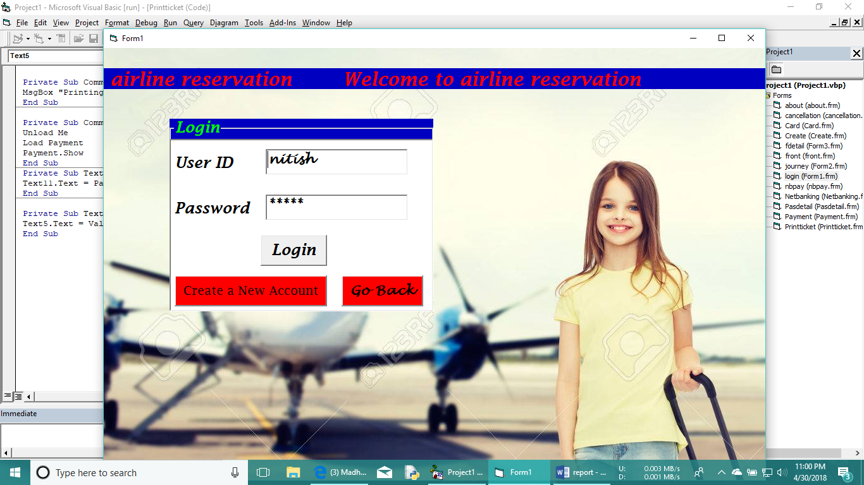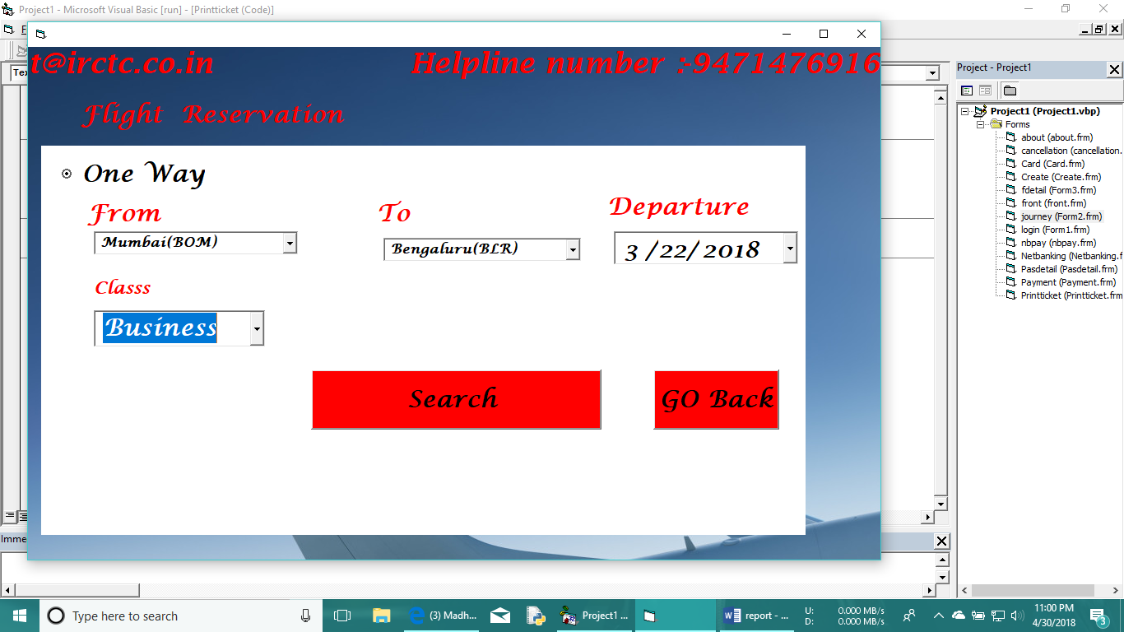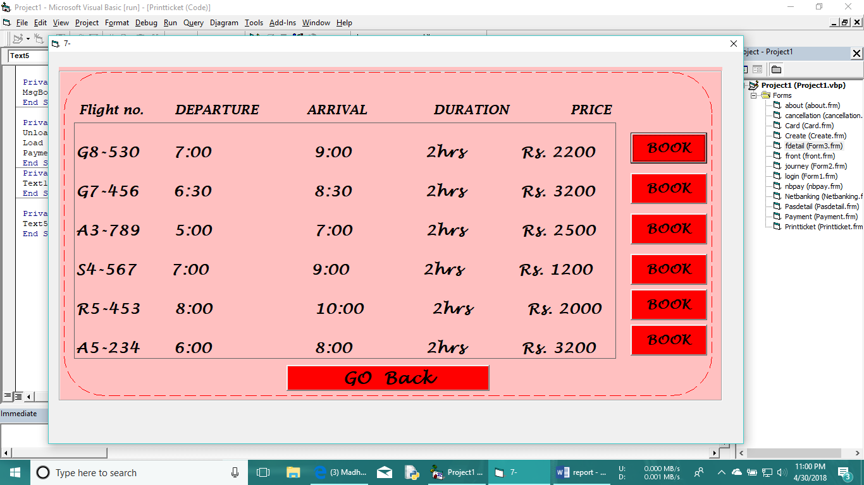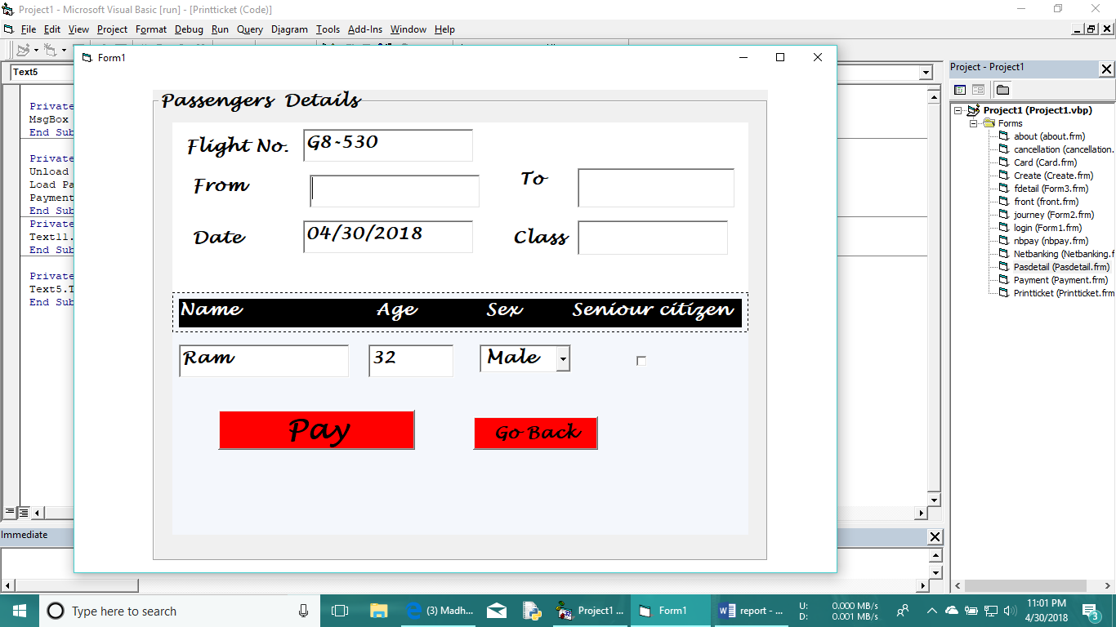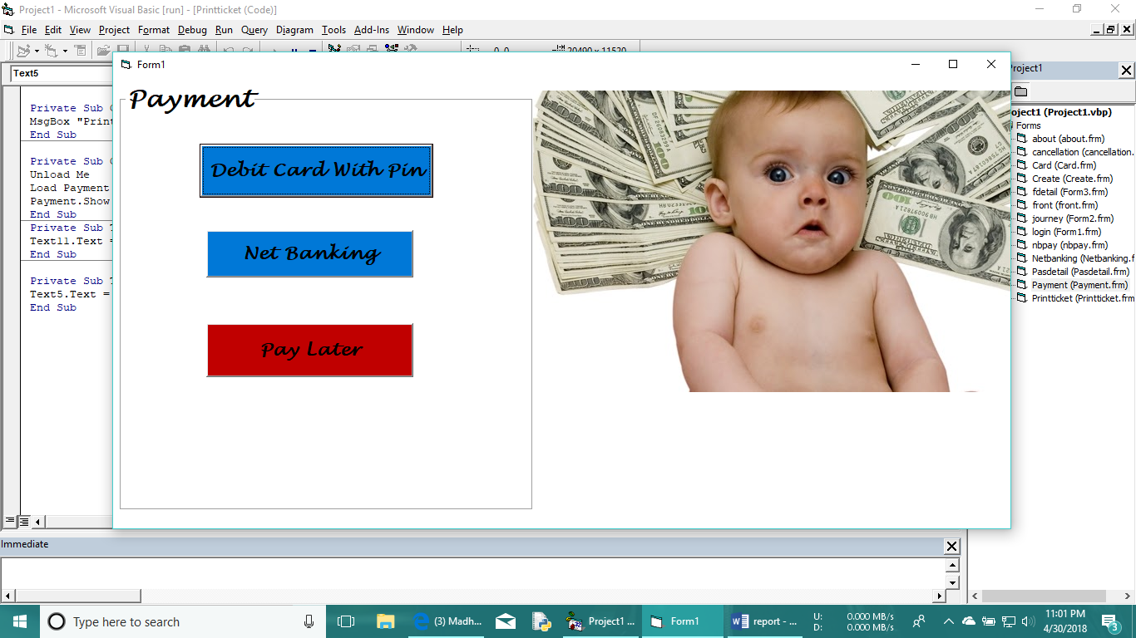 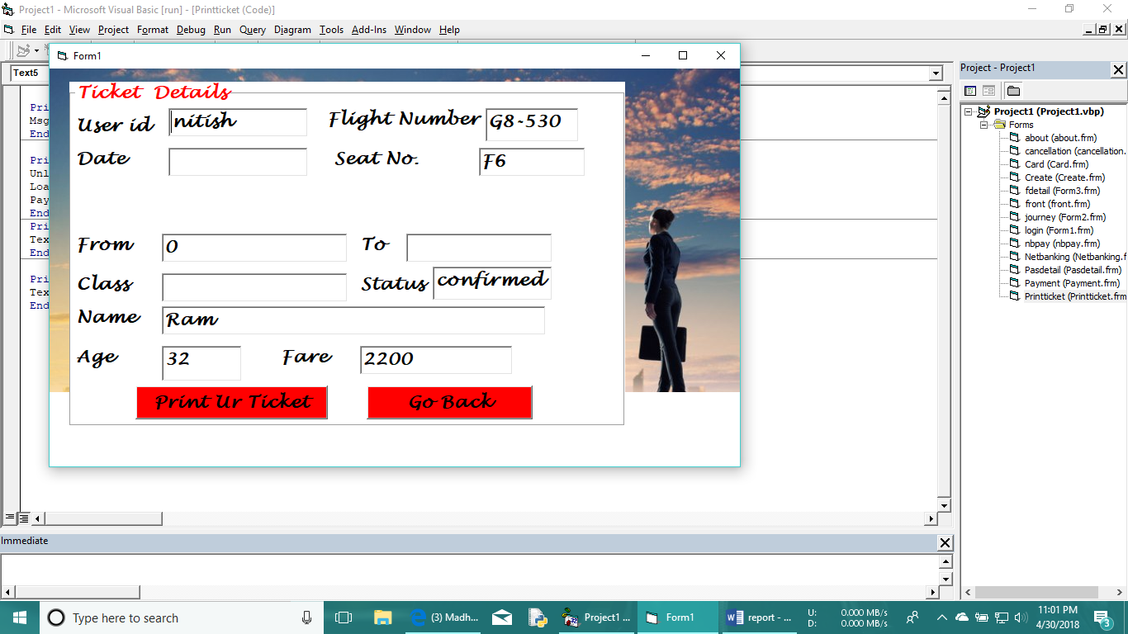

Sample Output

**TESTING**

In this phases I had tried to check all the modules separately for their proper formatting. After this step I had performed a unit test to check the functionality of the whole system.

Further I had come to know to add certain validation in project as given :-

1. Table name :-- Customer information

Field name –Customer name

Data type -Text.

When we enter number in the form then it show wrong .Because it is not number type .It is a character. So it show wrong value.

1. Table name _Customer information.

Field name- Departure time, Arrival time.

Data type- Date/Time.

When we enter 12.33 then it automatically show 12.33pm.

When we enter 11.33 then it automatically show 11.33am.

1. Table name –Flight information.

Field name- Flight-code.

Data type- number.

**When we Put any other value or character then it ask validity check.**

Airline Reservation System is one the modifications that were carried out in the Passenger Service System so that the working and availability of Service area can be broadened.

**Scope for future work**

This is basically an interface of Global distribution System to carry out reservations on the desired airline from any place. Airline Reservation System make the life of passengers very easy as they don’t need to stand in queues for getting their seats reserved and they can easily make reservations on any airline just from a single system. On the other hand, it also removed an extra burden from the Airline Department as most of the passengers and travel agencies use this service instead of making reservations from the counters.

With the help of this system, customers can view all the different flight’s availability with different timings for a particular date and it also allows them to reserve a seat, cancel a reservation or modify it. The only problem with the system is that it doesn’t allow the passengers to change the particular part of his or her reservation. Apart from the fight details, it also displays information that how many passengers are going to board a particular flight. The users follow the same steps no matter what is their mode of system access is, namely, phone, internet or the information desk at any part of the world, keeping consistency in the system.

ARS software is developed by many custom software development companies and then integrated into the website. The client puts forth their requisites and the development team produces software catering to their needs.

On one hand, it helps the customers and on the other, it also makes the life of the airline service companies easier by keeping all the records of the passengers and if there is any change in the fight due to some reason, the passengers are promptly informed. This system is also used by companies to keep track of user preferences of regular travelers so that they can provide better service and give offers to customers. It also helps in maximizing the revenue generation of the airline companies in various ways. The regular passengers can use this system to get the information regarding the special offers and discounts provided to them. For some travelers who travel in parts or have to travel to various destinations one after another, this system also guides them to select the best possible combination for them. Users can create their permanent accounts in the system and need not fill the required information every time they book, saving a lot of time of the customers.

**DEPLOYMENT DIAGRAM**

**MS ACCESS**

**RESERVE TICKET**

**FLIGHT STATUS**

**FLIGHT DETAILS**

Though the system still containing lot of scope of improvement in it. But its overall look and feel gives rough picture of on existing automation system. I have take MS-Access at backhand but it has a limitation of 1 GB size .It over datasize approaches this 1gb some other database the SQL server ,oracle, can be used with OBBC to break this barrier. 1. http://inkboard.sourceforge.net/docs/VisionDocument.pdf

**REFERENCES**

**CONCLUSION**

2. www.orbitz.com

3. www.wikipedia

4. [www.youtube.com](http://www.youtube.com)

***************THE END******************